**LAPORAN PENGEMBANGAN GAME NEZUKO RUN**



Disusun Oleh :

Nama : Bagas Kara Adi Pratama

NIM : A11.2016.09905

Kelas : A11.4507

Makul : Game Programming

**FAKULTAS ILMU KOMPUTER**

**UNIVERSITAS DIAN NUSWANTORO**

**SEMARANG**

**2022**

**Daftar Isi**

**Tentang Game** 2

**Deskripsi** 2

**Screenshot** 2

**Detail Pengembangan Aplikasi** 2

**Flowchart** 2

**Class Diagram** 3

**Screenshot Lebih Lengkap** 4

**Scene Game Menu** 4

**Scene Gameplay** 4

**Scene GameOver** 4

**Asset File** 5

**Source Code** 6

**Player Move** 6

**ObstacleInAct** 7

**Menu** 7

**GenerateObs** 8

**GameOver** 9

**Referensi** 9

**Gambar :** 9

**Sound :** 9

**Tutorial :** 9

# **Tentang Game**

## **Deskripsi**

Permainan **endless runner game** adalah jenis permainan yang tidak ada akhir, dan tujuan pemain adalah harus mendapatkan skor tertinggi. Dimana pemain hanya cukup melewati rintangan terus-menerus tanpa adanya batas waktu yang ditentukan.

## **Screenshot**

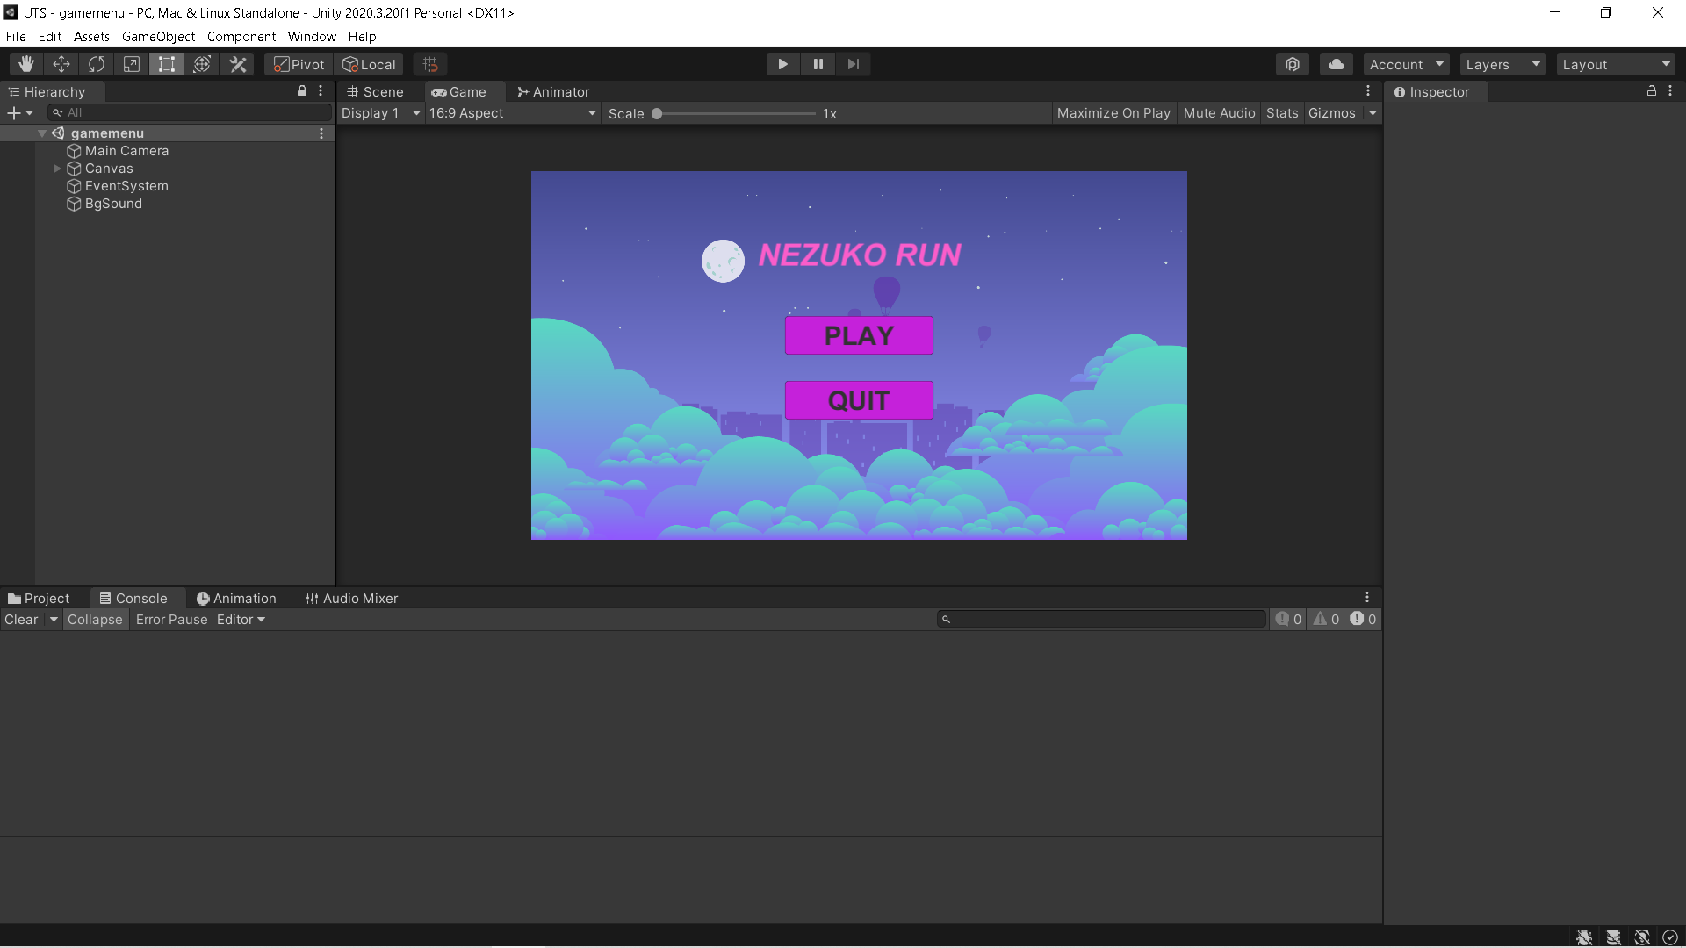

# **Detail Pengembangan Aplikasi**

## **Flowchart**

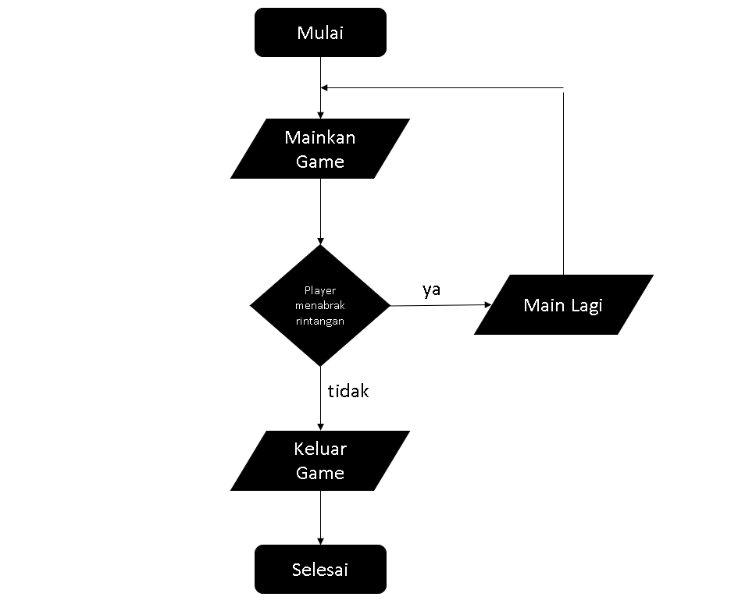

## **Class Diagram**

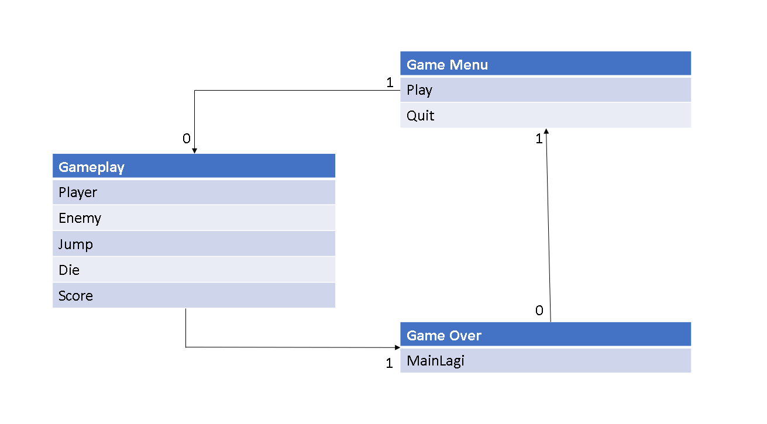

# **Screenshot Lebih Lengkap**

## **Scene Game Menu**

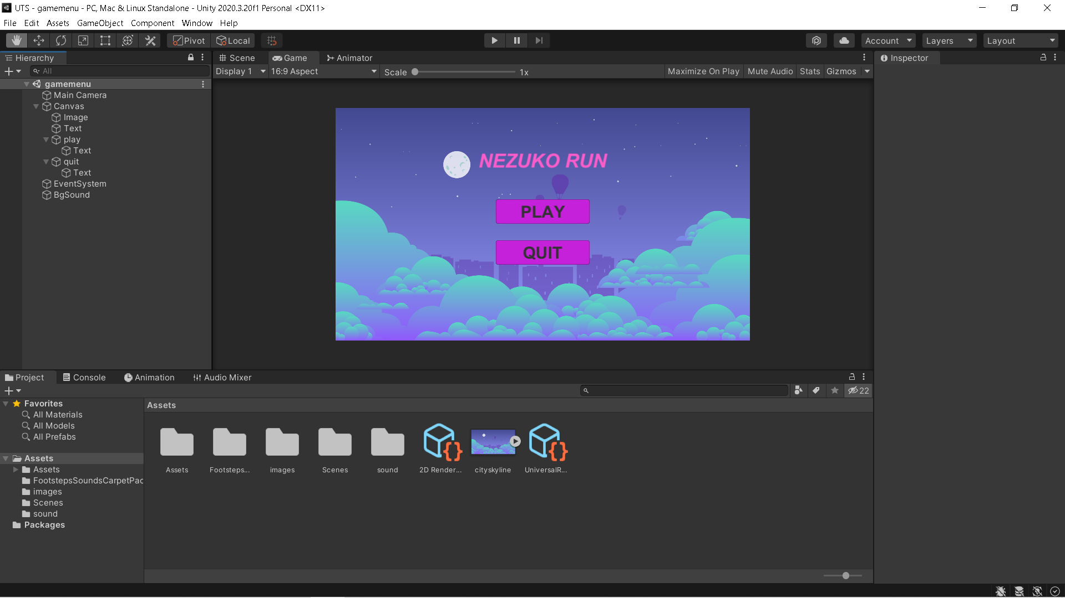

## **Scene Gameplay**

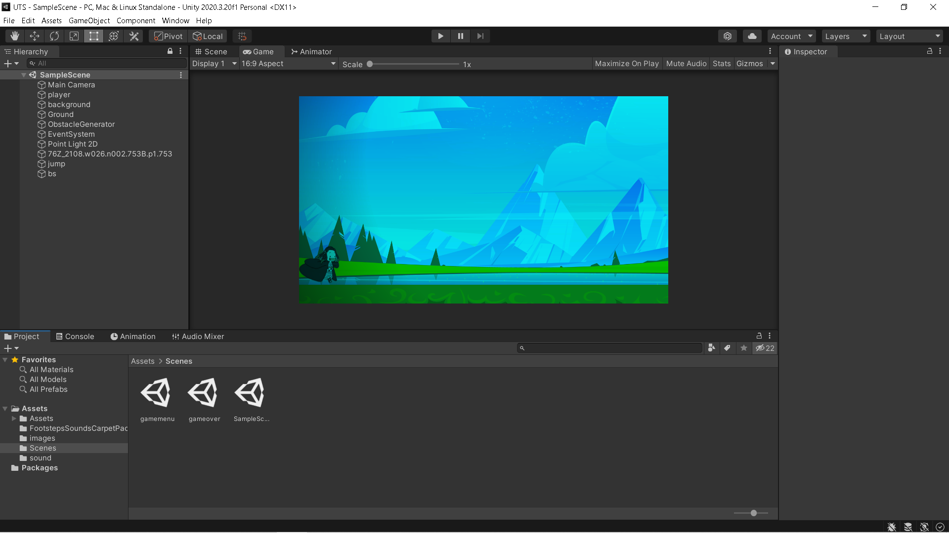

## **Scene GameOver**

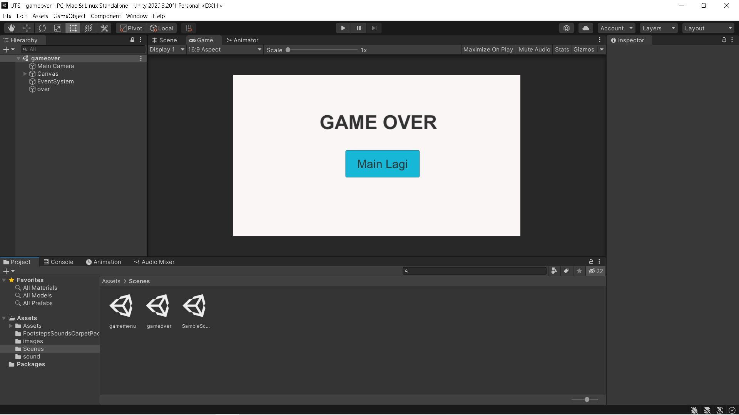

## **Asset File**

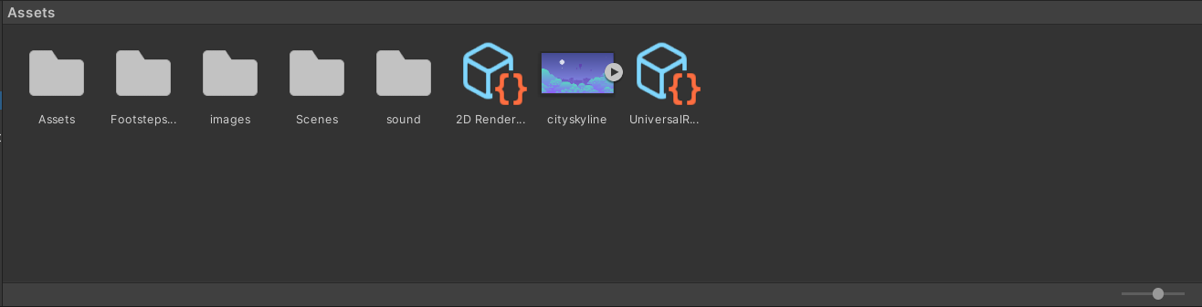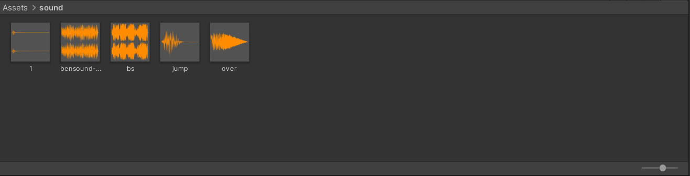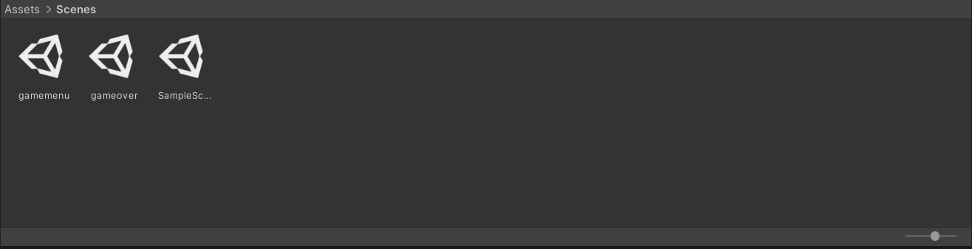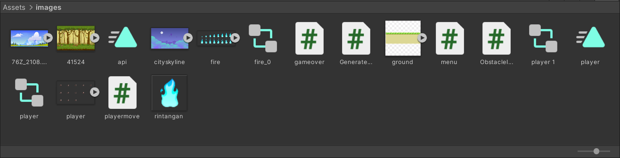

# **Source Code**

## **Player Move**

using System.Collections;

using System.Collections.Generic;

using UnityEngine;

using UnityEngine.SceneManagement;

public class playermove : MonoBehaviour

{

public float lompat;

[SerializeField]

bool isGrounded = false;

Rigidbody2D RB;

public AudioSource jump;

private void Awake()

{

RB = GetComponent<Rigidbody2D>();

}

// Update is called once per frame

void Update()

{

if (Input.GetKeyDown(KeyCode.UpArrow))

{

GetComponent<Rigidbody2D>().velocity = new Vector2(0, lompat);

if (isGrounded == true)

{

RB.AddForce(Vector2.up * lompat);

isGrounded = false;

}

jump.Play();

}

}

private void OnCollisionEnter2D(Collision2D collision)

{

if (collision.gameObject.CompareTag("ground"))

{

if (isGrounded == false)

{

isGrounded = true;

}

}

if (collision.gameObject.CompareTag("rintangan"))

{

Die();

}

}

void Die()

{

SceneManager.LoadScene("gameover");

}

}

## **ObstacleInAct**

using System.Collections;

using System.Collections.Generic;

using UnityEngine;

public class ObstacleInAct : MonoBehaviour

{

public Vector2 veloc = new Vector2(-4, 0);

void Start()

{

GetComponent<Rigidbody2D>().velocity = veloc;

float range = 2;

transform.position = new Vector3(transform.position.x, transform.position.y - range * Random.value, transform.position.z);

}

// Update is called once per frame

void Update()

{

}

}

## **Menu**

using System.Collections;

using System.Collections.Generic;

using UnityEngine;

using UnityEngine.UI;

using UnityEngine.SceneManagement;

public class menu : MonoBehaviour

{

// Start is called before the first frame update

void Start()

{

}

// Update is called once per frame

void Update()

{

}

public void LoadGame()

{

SceneManager.LoadScene("SampleScene");

}

public void QuitGame()

{

Debug.Log ("QUIT!");

Application.Quit();

}

}

## **GenerateObs**

using System.Collections;

using System.Collections.Generic;

using UnityEngine;

public class GenerateObs : MonoBehaviour

{

int score = 0;

public GameObject rocks;

void Start()

{

InvokeRepeating("CreateObstacle", 1f, 1.5f);

}

void CreateObstacle()

{

Instantiate(rocks);

score++;

}

void OnGUI()

{

GUI.color = Color.black;

GUILayout.Label("Score :" + score.ToString());

}

// Update is called once per frame

void Update()

{

}

}

## **GameOver**

using System.Collections;

using System.Collections.Generic;

using UnityEngine;

using UnityEngine.UI;

using UnityEngine.SceneManagement;

public class gameover : MonoBehaviour

{

public AudioSource over;

// Start is called before the first frame update

void Start()

{

over.Play();

}

// Update is called once per frame

void Update()

{

}

public void LoadGame()

{

SceneManager.LoadScene("gamemenu");

}

}

# **Referensi**

## **Gambar :**

https://pressstart.vip/assets

<http://heythatsmyartteacher.blogspot.com/2018/05/2d-scrolling-video-game-background.html>

<https://userstyles.org/styles/190701/nezuko-run-youtube>

## **Sound :**

https://www.bensound.com/

https://assetstore.unity.com/packages/audio/sound-fx/footsteps-sounds-carpet-pack-2924

<https://www.youtube.com/watch?v=NQMmZ4Psb7w&ab_channel=AnimenzPianoSheets>

<https://assetstore.unity.com/packages/audio/sound-fx/free-sfx-package-5178>

## **Tutorial :**

https://www.youtube.com/watch?v=QSTKy9cHmcI&t=389s&ab_channel=gamesplusjames

https://www.youtube.com/watch?v=8pFlnyfRfRc&ab_channel=AlexanderZotov

https://www.youtube.com/watch?v=HBd-0QAP470&t=183s&ab_channel=Akkiindiegamedev

https://www.youtube.com/watch?v=-ntmVGo-1vs&t=126s&ab_channel=NicWu

https://www.youtube.com/watch?v=Juzz_OaBVrI&t=261s&ab_channel=RxunitRohit

https://www.youtube.com/watch?v=EciYWWDIgB8&t=121s&ab_channel=TheGameGuy

https://www.youtube.com/watch?v=BKCsH8mQ-lM&t=71s&ab_channel=SpeedTutor

https://www.youtube.com/watch?v=Py8akSRnwuI&ab_channel=CodeMonkey

https://www.youtube.com/watch?v=RsgiYqLID-U&t=722s&ab_channel=CocoCode

https://www.youtube.com/watch?v=cj6hwCjiVZE&ab_channel=JimmyVegas

https://www.youtube.com/watch?v=zc8ac_qUXQY&t=496s&ab_channel=Brackeys

https://www.youtube.com/watch?v=-GWjA6dixV4&ab_channel=BMo

https://www.youtube.com/watch?v=wW8PBIzQkzk

https://www.youtube.com/watch?v=w81Vnallov0&ab_channel=DenySuhendraProject

https://www.youtube.com/watch?v=Gi1FqqPuQwc&ab_channel=AryaPradata

https://www.youtube.com/watch?v=zPPcjRndM4A&ab_channel=EL_Ghifariansyah

https://www.youtube.com/watch?v=xcmYsc2BY-U&ab_channel=TheGameGuy

https://www.youtube.com/watch?v=zKG8gSrwbnQ&t=397s&ab_channel=AlexanderZotov

https://www.youtube.com/watch?v=cG2Jka1JRhU&t=614s&ab_channel=AkbarProject